# Crop Yield Prediction - Web Output
---

## . Homepage UI Display
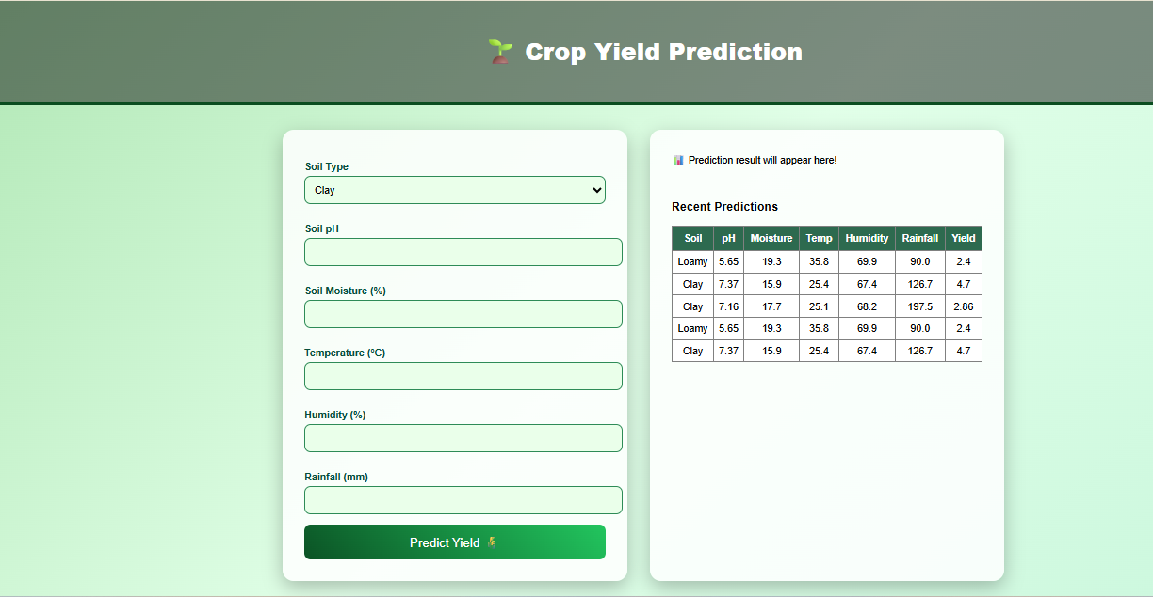
---

## Sample Input Used
Soil Type: Sandy
Soil pH: 5.9
Soil Moisture: 24.1%
Temperature: 26.1 °C
Humidity: 51.3 %
Rainfall: 95.5 mm

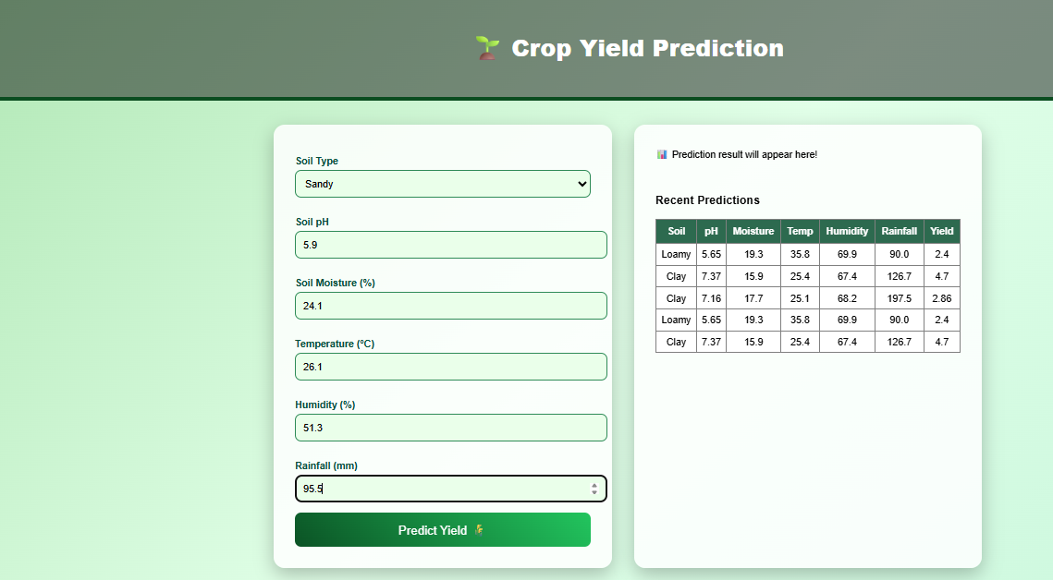
---

## Output Display Screenshot
Prediction shown to user after clicking “Predict Yield”




